To add a link on the horizontal menu bar of your website to the new Join Cochrane pages, two steps are required:
- To unpublish the existing Get Involved page, if any.
- To create a new menu item pointing to Join Cochrane on the menu bar.
Note: Make sure that by adding the Join Cochrane link, the horizontal menu bar does not extend over two lines. If this is the case, revise the list of the links by, for example, shortening their text or by removing one of them or by grouping two or more under a single section.
Also: Make sure that no other pages are pointing to your old Get Involved page. In case, run a search in your website, using the top right-hand search box, for example for ‘involved’ or ‘get inv’ or anything more specific.
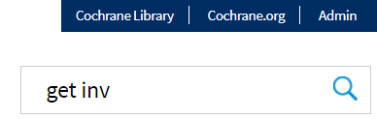
Then, edit the page(s) pointing to your old Get Involved page and remove/update the old links.

Unpublish existing Get Involved page
- Edit the existing Get Involved page.
If you are not sure whether your site has one, from the top black admin menu, click on the Content menu to access the Content summary page.
  - Search for a page with Get in its title.
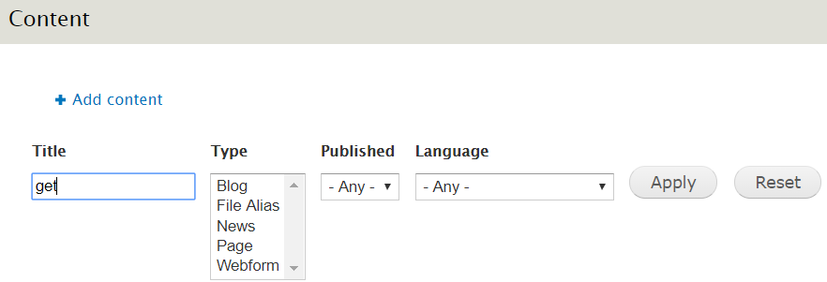
  - If the search is successful, click on the Edit link to edit the page.
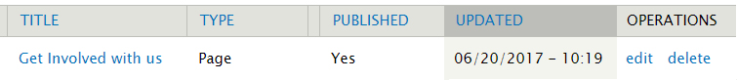
- Scroll down the window to get to and click on the Publishing options section: here, deselect the Published checkbox.
- Save.
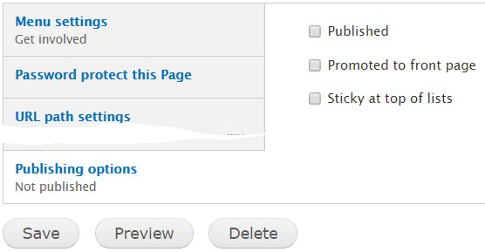

Create a new menu item for Join Cochrane
- From the top black admin menu, select Structure > Menus > Main Menu to access the Main Menu summary page.
- Click on the Add link link.
- In the appearing form:
  - Insert Join Cochrane in the Menu link title field.
  - Insert http://join.cochrane.org/ in the Path field.
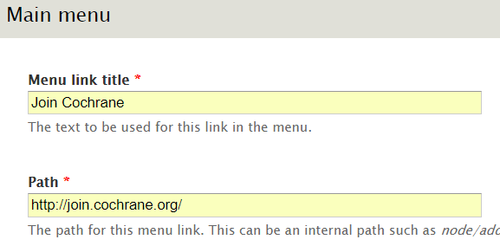
  - Scroll down and click on MENU LINKS ATTRIBUTES to expand the corresponding section.
  - From the Target drop-down list, select New window (_blank).
  - Scroll down to the bottom and click on Save.
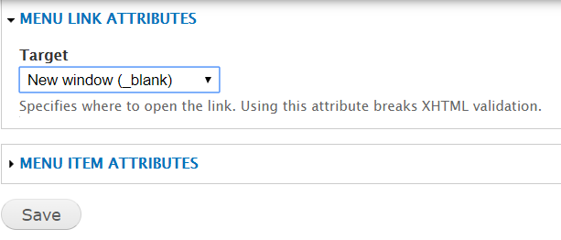
- In case, rearrange the position of the new menu item by dragging, moving left of right and dropping the anchor that’s right before it. Then click on Save configuration.
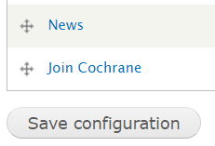
More info on how to manage Menus and menu links are available in the Admin manual at
http://community.cochrane.org/sites/default/files/uploads/inline-files/WebsiteAdminManual.pdf - also available from the Help menu of the top black admin menu.
For any further assistance, email support@cochrane.org.

