Worksheet:

Reading Forest Plots

Have a look at the forest plots below and answer the questions that follow:

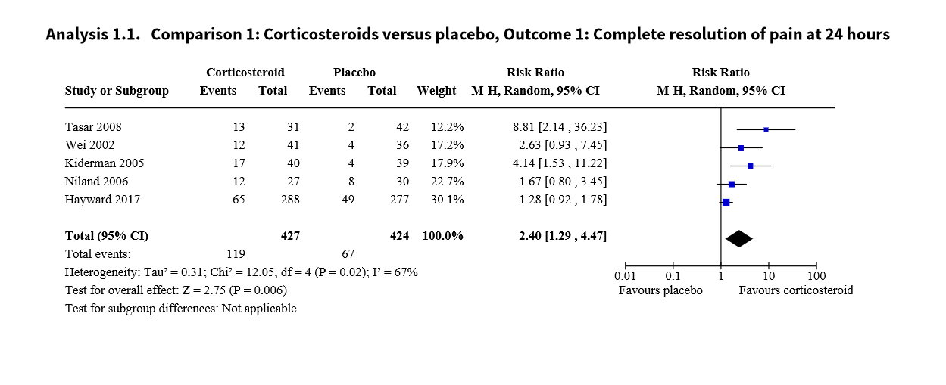
Forest plot 1:

What are the two groups being compared in the forest plots?
Corticosteroids vs. placebo

What is the outcome addressed in the forest plot?
Complete resolution of pain at 24 hours

What type of meta-analysis was done?
Mantel-Haenszel

How many studies were included in the meta-analysis?
5

What was the total number of participants included in the meta-analysis?
427+424=851

Which study added the most weight to the analysis?
Hayward 2017 (30.1%)

What measure of effect was used?
Risk ratio

Which study showed the biggest effect?
Tasar 2008 (RR=8.81)

What was the overall pooled effect?
RR=2.40

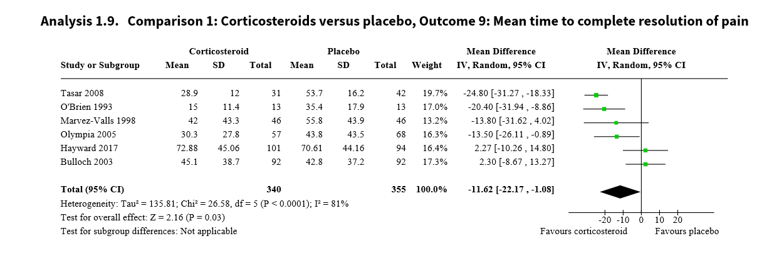
Forest plot 2:

What are the two groups being compared in the forest plots?
Corticosteroids vs. placebo

What is the outcome addressed in the forest plot?
Mean time to complete resolution of pain

What type of meta-analysis was done?
Inverse-variance

How many studies were included in the meta-analysis?
6

What was the total number of participants included in the meta-analysis?
340+355=695

Which study added the most weight to the analysis?
Tasar 2008 (19.7%)

What measure of effect was used?
Mean difference

Which study showed the biggest effect?
Tasar 2008 (MD= -24.80)

What was the overall pooled effect?
MD= -11.62

de Cassan S, Thompson MJ, Perera R, Glasziou PP, Del Mar CB, Heneghan CJ, Hayward G. Corticosteroids as standalone or add-on treatment for sore throat. Cochrane Database of Systematic Reviews 2020, Issue 5. Art. No.: CD008268. DOI: 10.1002/14651858.CD008268.pub3.

