Worksheet:

Reading Forest Plots

Have a look at the forest plots below and answer the questions that follow:

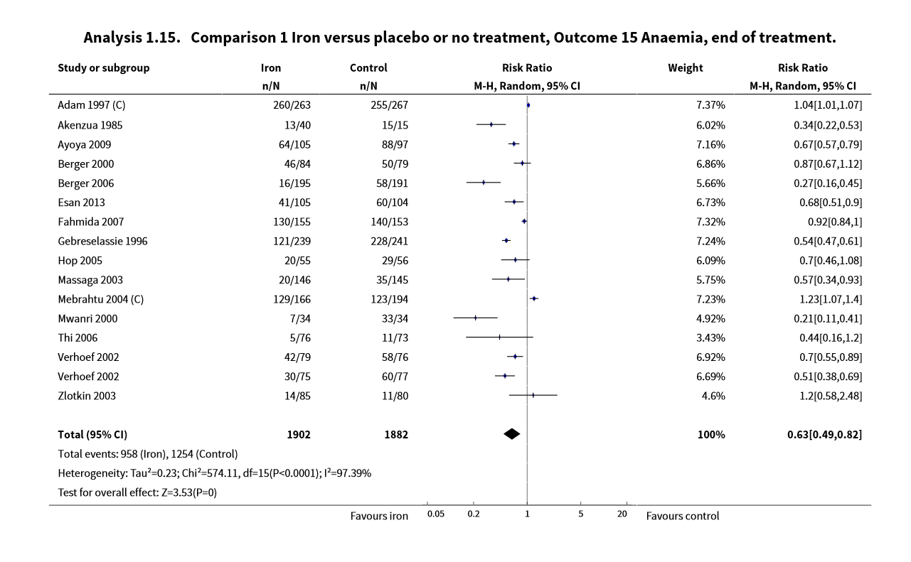
Forest plot 1:

What are the two groups being compared in the forest plots?
Iron vs. placebo or no treatment

What is the outcome addressed in the forest plot?
Anaemia at end of treatment

What type of meta-analysis was done?
Mantel Haenszel

How many studies were included in the meta-analysis?
16

What was the total number of participants included in the meta-analysis?
1902+1882=3784

Which study added the most weight to the analysis?
Adam 1007 (7.37%)

What measure of effect was used?
Risk Ratio

Which study showed the biggest effect?
Mwanri 2000 (RR=0.21)

What was the overall pooled effect?
RR=0.63

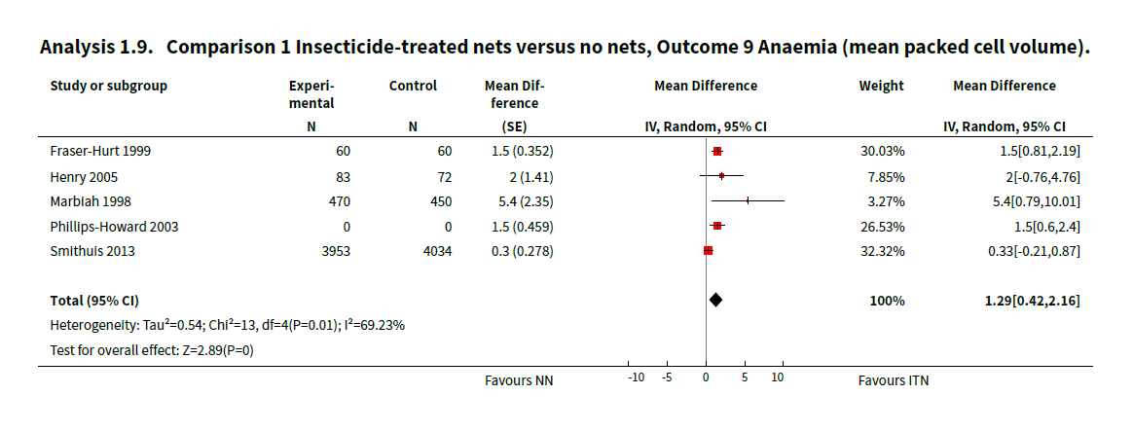
Forest Plot 2:

What are the two groups being compared in the forest plots?
Insecticide-treated nets vs. no nets

What is the outcome addressed in the forest plot?
Anaemia (mean packed cell volume)

What type of meta-analysis was done?
Inverse-variance

How many studies were included in the meta-analysis?
5

What was the total number of participants included in the meta-analysis?
9182 (need to add all the participants in the experimental and control group)

Which study added the most weight to the analysis?
Smithuis 2013 (32.32%)

What measure of effect was used?
Mean difference

Which study showed the biggest effect?
Marblah 1998 (MD=5.4)

What was the overall pooled effect?
MD=1.29

Neuberger A, Okebe J, Yahav D, Paul M. Oral iron supplements for children in malaria-endemic areas. Cochrane Database of Systematic Reviews 2016, Issue 2. Art. No.: CD006589. DOI: 10.1002/14651858.CD006589.pub4.
Pryce_J, Richardson_M, Lengeler_C. Insecticide-treated nets for preventing malaria. Cochrane Database of Systematic Reviews 2018, Issue 11. Art. No.: CD000363. DOI: 10.1002/14651858.CD000363.pub3.

