Worksheet:

Reading Forest Plots

Have a look at the forest plots below and answer the questions that follow:

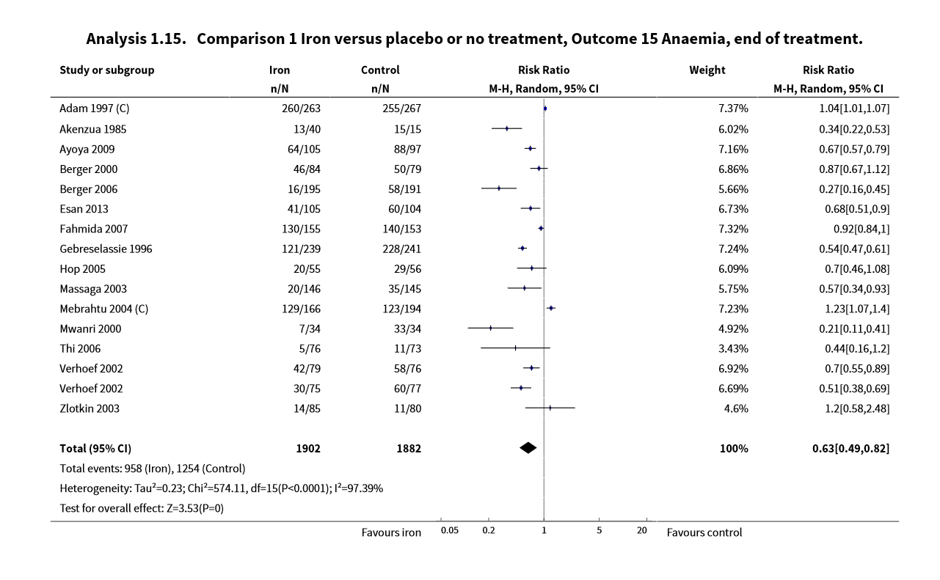
Forest plot 1:

What are the two groups being compared in the forest plots?

What is the outcome addressed in the forest plot?

What type of meta-analysis was done?

How many studies were included in the meta-analysis?

What was the total number of participants included in the meta-analysis?

Which study added the most weight to the analysis?

What measure of effect was used?

Which study showed the biggest effect?

What was the overall pooled effect?

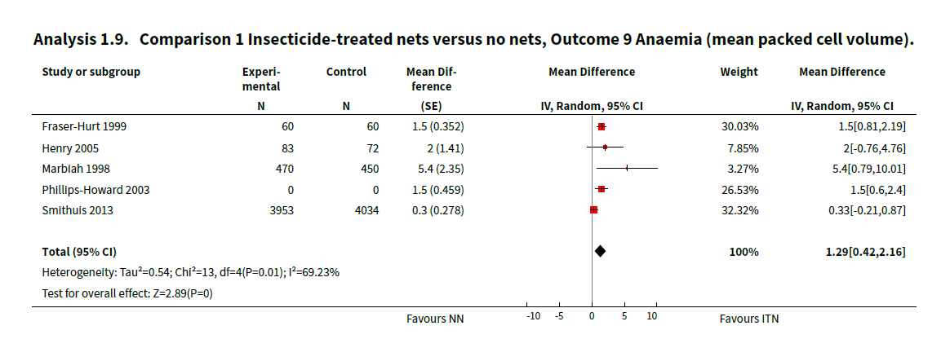
Forest Plot 2:

What are the two groups being compared in the forest plots?

What is the outcome addressed in the forest plot?

What type of meta-analysis was done?

How many studies were included in the meta-analysis?

What was the total number of participants included in the meta-analysis?

Which study added the most weight to the analysis?

What measure of effect was used?

Which study showed the biggest effect?

What was the overall pooled effect?

Neuberger A, Okebe J, Yahav D, Paul M. Oral iron supplements for children in malaria-endemic areas. Cochrane Database of Systematic Reviews 2016, Issue 2. Art. No.: CD006589. DOI: 10.1002/14651858.CD006589.pub4.
Pryce_J, Richardson_M, Lengeler_C. Insecticide-treated nets for preventing malaria. Cochrane Database of Systematic Reviews 2018, Issue 11. Art. No.: CD000363. DOI: 10.1002/14651858.CD000363.pub3.

