Worksheet: Dichotomous data

Read the abstract below and answer the questions that follow:

Physical exercise programme during pregnancy decreases perinatal depression risk: a randomised controlled trial
Marina Vargas-Terrones, Ruben Barakat, Belen Santacruz, Irene Fernandez-Buhigas, Michelle F Mottola
Br J Sports Med. 2019 Mar;53(6):348-353. doi: 10.1136/bjsports-2017-098926. Epub 2018 Jun 13.
Introduction: The incidence of depression is high during the perinatal period. This mood disorder can have a significant impact on the mother, the child and the family.
Objective: To examine the effect of an exercise programme during pregnancy on the risk of perinatal depression.
Methods: Healthy women who were <16 weeks pregnant were randomly assigned to two different groups. Women in the intervention group participated in a 60 min exercise programme throughout pregnancy, 3 days per week, which was conducted from October 2014 to December 2016. The Center for Epidemiological Studies-Depression Scale was used to measure the risk of depression at the beginning of the study (12-16 weeks), at gestational week 38 and at 6 weeks postpartum.
Results: One hundred and twenty-four pregnant women were allocated to either the intervention (IG=70) or the control (CG=54) group. No differences were found in the percentage of depressed women at baseline (20% vs 18.5%) (χ2=0.043; p=0.836). Using per protocol analysis, 13 of 70 women in the IG compared to 16 of 45 women in the CG experienced depression at 38 weeks gestational age. At 6 weeks postpartum, 10 of 69 women in the IG compared to 14 of 47 women in the CG were depressed.
Conclusion: An exercise programme performed during pregnancy may reduce the prevalence of depression in late pregnancy and postpartum.

Answer the questions below.
- What was the risk of depression at 38 weeks gestational age among participants in the intervention group?
13/70=0.19 or 19%
- What was the risk of depression at 38 weeks gestational age among participants in the control group?
16/54=0.3 or 30%
- Calculate the relative risk (RR) for the outcome depression at 38 weeks gestational age.
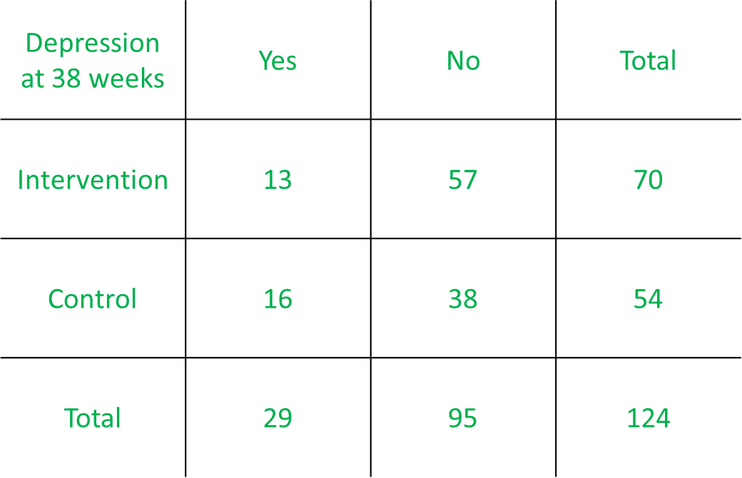
0.19/0.3=0.63

- How would you express the RR in words? Select all that apply. (Correct answers highlighted)
- Women in the intervention group were 0.63 times as likely to report depression at 38 weeks gestational age compared to women in the control group.
- Women in the intervention group were 0.37 times as likely to report depression at 38 weeks gestational age compared to women in the control group.
- The risk of depression at 38 weeks gestational age was reduced by 63% in women in the intervention group compared to women in the control group.
- The risk of depression at 38 weeks gestational age was reduced by 37% in women in the intervention group compared to women in the control group.

- Calculate the RR for the outcome depression at 6 weeks postpartum.
(10/69)/(14/47)=0.49
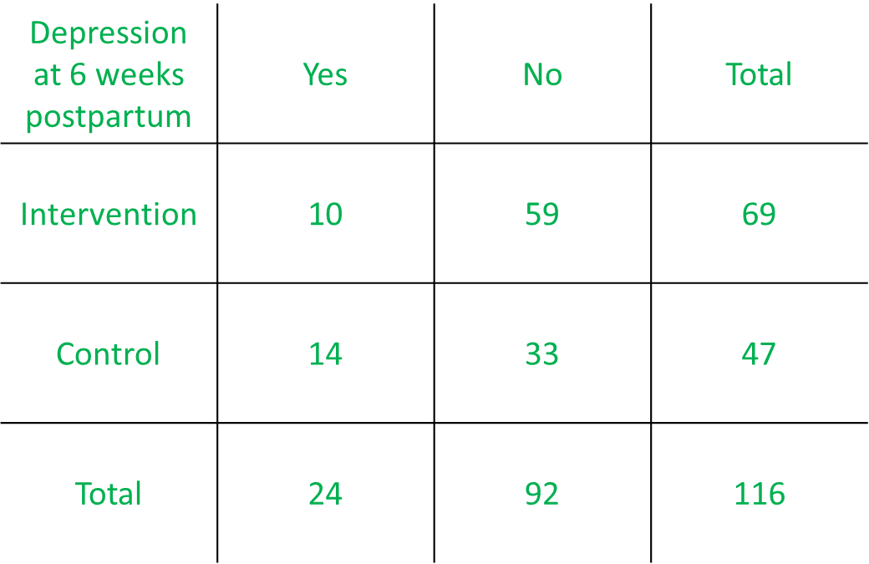
- Express the RR in words.
Women in the intervention group were 0.49 times as likely to report depression at 6 weeks postpartum compared to women in the control group.

OR

The risk of depression at 6 weeks postpartum was reduced by 51% in women in the intervention group compared to women in the control group.

- Calculate the odds ratio (OR) for the outcome depression at 6 weeks postpartum.
(10/59)/(14/33)=0.4
OR
(10*33)/(14*59)=0.4
- Express the OR in words.
The odds of depression at 6 weeks among women in the intervention group was 0.4 times the odds of depression at 6 weeks among women in the control group.
OR
The odds of depression at 6 week postpartum was reduced by 60% in women in the intervention group compared to women in the control group.

The abstract has been modified for the purpose of this exercise.

