Worksheet: Dichotomous data

Read the abstract below and answer the questions that follow:

Effect of Oral Dexamethasone Without Immediate Antibiotics vs Placebo on Acute Sore Throat in Adults: A Randomized Clinical Trial
Gail Nicola Hayward, Alastair D Hay, Michael V Moore, Sena Jawad, Nicola Williams, Merryn Voysey, Johanna Cook, Julie Allen, Matthew Thompson, Paul Little, Rafael Perera, Jane Wolstenholme, Kim Harman, Carl Heneghan

JAMA. 2017 Apr 18;317(15):1535-1543. doi: 10.1001/jama.2017.3417.
Importance: Acute sore throat poses a significant burden on primary care and is a source of inappropriate antibiotic prescribing. Corticosteroids could be an alternative symptomatic treatment.
Objective: To assess the clinical effectiveness of oral corticosteroids for acute sore throat in the absence of antibiotics.
Design, setting, and participants: Double-blind, placebo-controlled randomized trial (April 2013-February 2015; 28-day follow-up completed April 2015) conducted in 42 family practices in South and West England, enrolled 576 adults recruited on the day of presentation to primary care with acute sore throat not requiring immediate antibiotic therapy.
Interventions: Single oral dose of 10 mg of dexamethasone (n = 293) or identical placebo (n = 283).
Main outcomes and measures: Primary: proportion of participants experiencing complete resolution of symptoms at 24 hours. Secondary: complete resolution at 48 hours, duration of moderately bad symptoms (based on a Likert scale, 0, normal; 6, as bad as it could be), visual analog symptom scales (0-100 mm; 0, no symptom to 100, worst imaginable), health care attendance, days missed from work or education, consumption of delayed antibiotics or other medications, adverse events.
Results: Among 565 eligible participants who were randomized (median age, 34 years [interquartile range, 26.0-45.5 year]; 75.2% women; 100% completed the intervention), 288 received dexamethasone; 277, placebo. At 24 hours, 65 participants in the dexamethasone group and 49 in the placebo group achieved complete resolution of symptoms. At 48 hours, 102 participants in the dexamethasone group vs 75 in the placebo group achieved complete resolution of symptoms. This difference also was observed in participants not offered delayed antibiotic prescription, in 65 of 173 patients in the dexamethasone group and 46 of 169 patients in the placebo group. There were no significant differences in any other secondary outcomes.
Conclusions and relevance: Among adults presenting to primary care with acute sore throat, a single dose of oral dexamethasone compared with placebo did not increase the proportion of patients with resolution of symptoms at 24 hours. However, there was a significant difference at 48 hours.
Trial registration: isrctn.org Identifier: ISRCTN17435450

Answer the questions below.
- What was the risk of achieving complete resolution of symptoms at 24 hours in the dexamethasone group?
65/288=0.23 or 23%
- What was the risk of achieving complete resolution of symptoms at 24 hours in the placebo group?
49/277=0.18 or 18%
- Calculate the relative risk (RR) for the outcome resolution of symptoms at 24 hours.
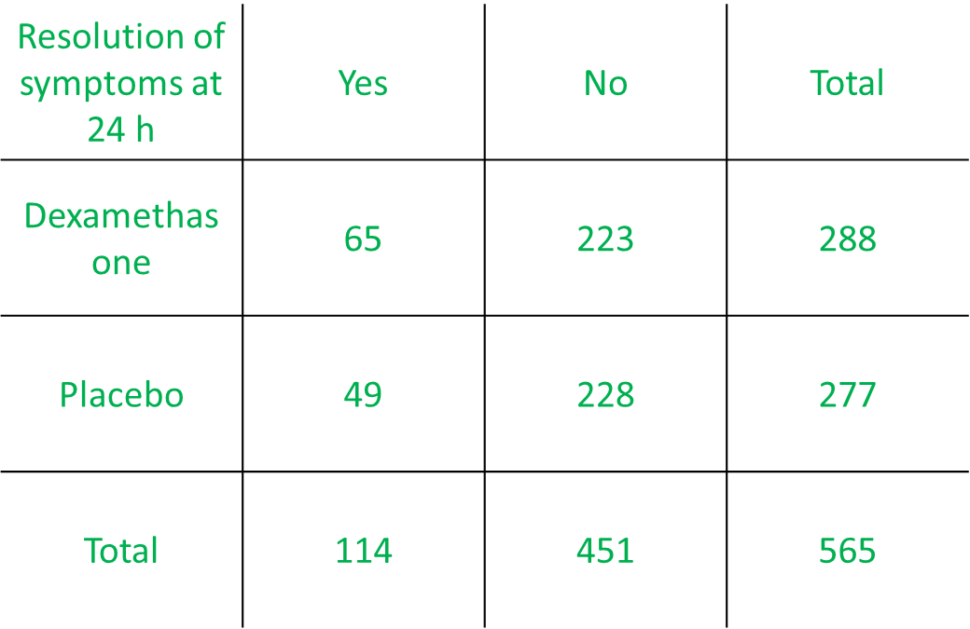
0.23/0.18=1.3

- How would you express the RR in words? Select all that apply. (correct answers highlighted).
- Patients receiving dexamethasone were 1.3 times as likely to have resolution of symptoms at 24 hours compared to patients receiving placebo.
- Patients receiving dexamethasone were 0.3 times as likely to have resolution of symptoms at 24 hours compared to patients receiving placebo.
- The risk of resolution of symptoms at 24 hours was increased by 30% among patients receiving dexamethasone compared to patients receiving placebo.
- The risk of resolution of symptoms at 24 hours was increased by 130% among patients receiving dexamethasone compared to patients receiving placebo.

- Calculate the odds ratio (OR) for the outcome resolution of symptoms at 48 hours.
(102/186)/(75/202)=1.48
OR
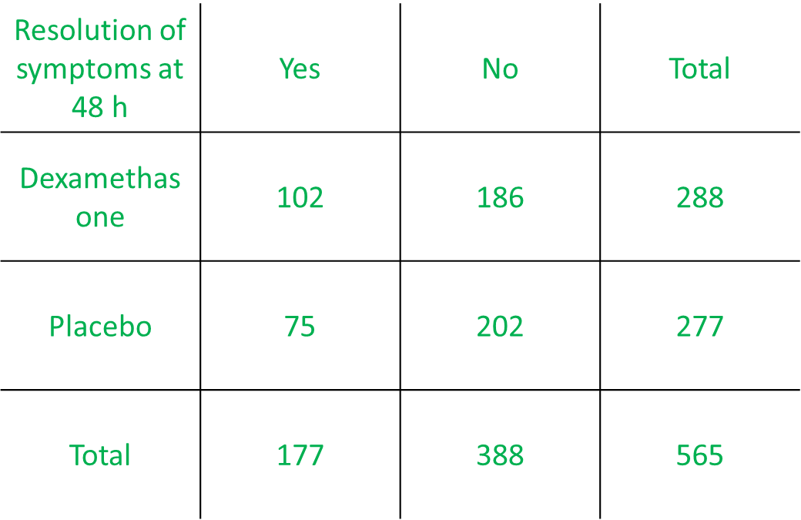
(102*202)/(75*186)=1.48

- Express the OR in words.
The odds of resolution of symptoms at 48 hours among patients receiving dexamethasone was 1.48 times the odds of resolution of symptoms at 48 hours among patients receiving placebo.
OR
The odds of resolution of symptoms at 48 hours increased by 48% among patients receiving dexamethasone compared to patients receiving placebo.

- Calculate the OR for outcome resolution of symptoms at 48 hours among participants not offered delayed antibiotic prescription.
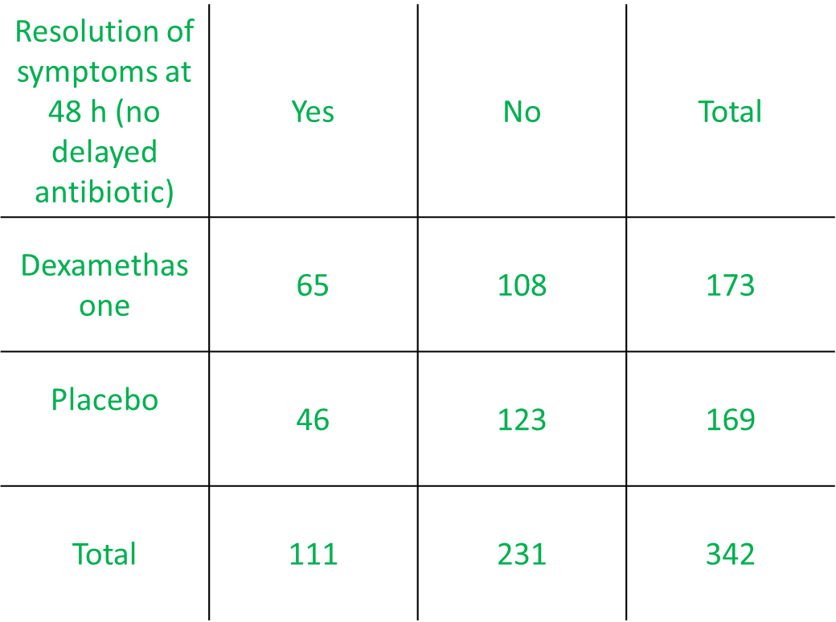
(65/108)/(46/123)=1.6
OR
(65*123)/(46*108)=1.6
- Express the OR in words.
The odds of resolution of symptoms at 48 hours without delayed antibiotics among patients receiving dexamethasone was 1.6 times the odds of resolution of symptoms at 48 hours without delayed antibiotics among patients receiving placebo.

OR

The odds of resolution of symptoms at 48 hours without delayed antibiotics increased by 60% among patients receiving dexamethasone compared to patients receiving placebo.

The abstract has been modified for the purpose of this exercise.

