Worksheet: Dichotomous data

Read the abstract below and answer the questions that follow:

Family-Based Smoking Cessation Intervention for Smoking Fathers and Non-smoking Mothers with a Child: A Randomized Controlled Trial
Sophia Siu Chee Chan, Yee Tak Derek Cheung, Daniel Yee Tak Fong, Karen Emmons, Angela Yee Man Leung, Doris Yin Ping Leung, Tai Hing Lam
J Pediatr. 2017 Jun;185:255. doi: 10.1016/j.jpeds.2017.03.002. PMID: 28746038
Objective: To examine whether a family-based intervention targeting both smoking fathers and non-smoking mothers in well-child health clinics is effective in increasing fathers' abstinence from cigarette smoking.
Study design: This parallel 2-arm randomized controlled trial recruited a total of 1158 families with a daily-smoking father, a non-smoking mother, and a child aged 0-18 months from the 22 maternal and child health centers in Hong Kong. The intervention group received the family-based intervention, including 6 nurse-led individual face-to-face and telephone counseling sessions within 1 month after recruitment and a voluntary face-to-face family counseling session (FCS). The control group received a leaflet, a self-help booklet, and brief quitting advice only. Father-reported 7-day and 6-month abstinence, smoking reduction, quit attempts, mother-reported help and support, and child salivary cotinine level were assessed at 12 months. Generalized estimating equation models were used to compare these outcomes between the 2 study groups.
Results: 598 mothers were randomised to the intervention group and 560 to the control group. At 12 month follow-up, 82 fathers in the intervention group reported 7-day abstinence compared to 45 fathers in the control group. Similarly, 80 fathers in the intervention group reported 6 month abstinence compared to 42 fathers in the control group. 114 fathers in the intervention group reported quit attempts with smoking abstinence for more than 24h, compared to 82 fathers in the control group. Within the intervention group, compared with receipt of individual counseling only, participation in the FCS was associated with increases in fathers' self-reported abstinence (20.2% vs 12.3%; P = .02), mothers' help (66.1% vs 43.8%; P < .01), and support to the fathers (55.0% vs 45.4%; P < .01).
Conclusions: The family-based smoking cessation intervention for the families in the well-child healthcare setting was effective in increasing the fathers' self-reported abstinence. Additional participation in the FCS increased mothers' help and support to the fathers.
Trial registration: Controlled-trials.com: ISRCTN99111655; Hkuctr.com: HKUCTR-465.
Keywords: child; cotinine; father; secondhand smoke; smoking cessation.

Answer the questions below.
- What was the risk of 7-day abstinence at 12 month follow-up among fathers receiving the family based intervention?
82/598=0.14 or 14%
- What was the risk of 7-day abstinence at 12 month follow-up among fathers receiving the leaflet, self-help guide and brief quitting advice (control)?
45/560=0.08 or 8%
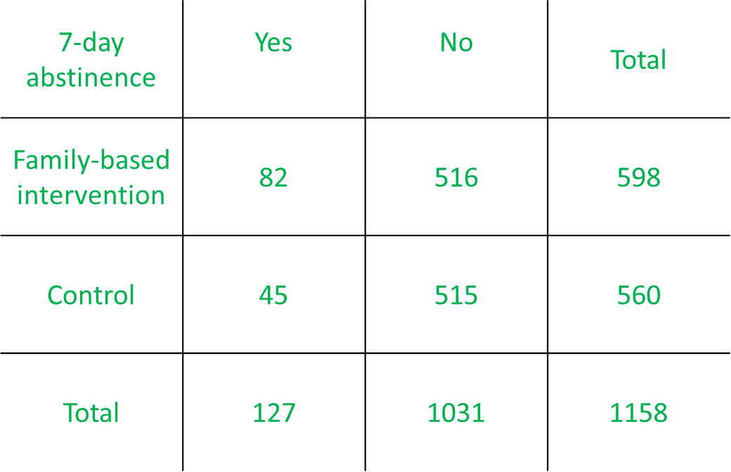
- Calculate the relative risk (RR) for the outcome 7-day abstinence at 12 month follow-up.
0.41/0.08=1.75

- How would you express the RR in words? Select all that apply. (correct answers highlighted)
- Fathers receiving the family-based intervention were 1.75 times as likely to report 7-day abstinence at 12 month follow-up compared to fathers receiving a leaflet, self-help guide and brief quitting advice.
- Fathers receiving the family-based intervention were 0.75 times as likely to report 7-day abstinence at 12 month follow-up compared to fathers receiving a leaflet, self-help guide and brief quitting advice.
- The risk of reporting 7-day abstinence at 12 month follow-up was increased by 75% among fathers who received the family-based intervention compared to those who received the leaflet, self-help guide and brief quitting advice.
- The risk of reporting 7-day abstinence at 12 month follow-up was increased by 175% among fathers who received the family-based intervention compared to those who received the leaflet, self-help guide and brief quitting advice.

- Calculate the odds ratio (OR) for 6 month abstinence at 12 month follow-up.
(80/518)/(42/518)=1.9
OR
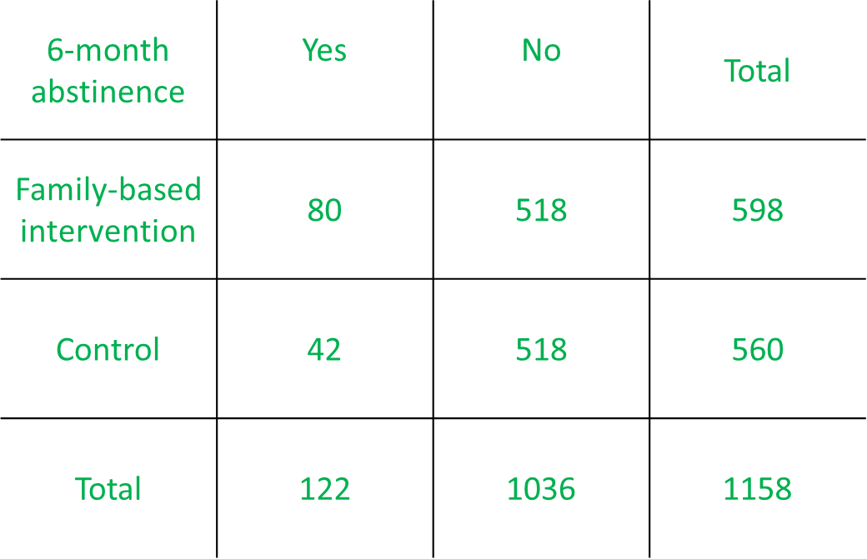
(80*518)/(42*518)=1.9

- Express the OR in words.
The odds of reporting 6-month abstinence at 12 month follow-up among fathers receiving the family-based intervention was 1.9 times the odds of reporting 6-month abstinence among fathers receiving the leaflet self-help guide and brief counselling.
OR
The odds of reporting 6-month abstinence at 12 month follow-up among fathers receiving the family-based intervention was increased by 90% compared to fathers receiving the leaflet self-help guide and brief counselling.

- Calculate the RR for quit attempts and abstinence for more than 24 hours.
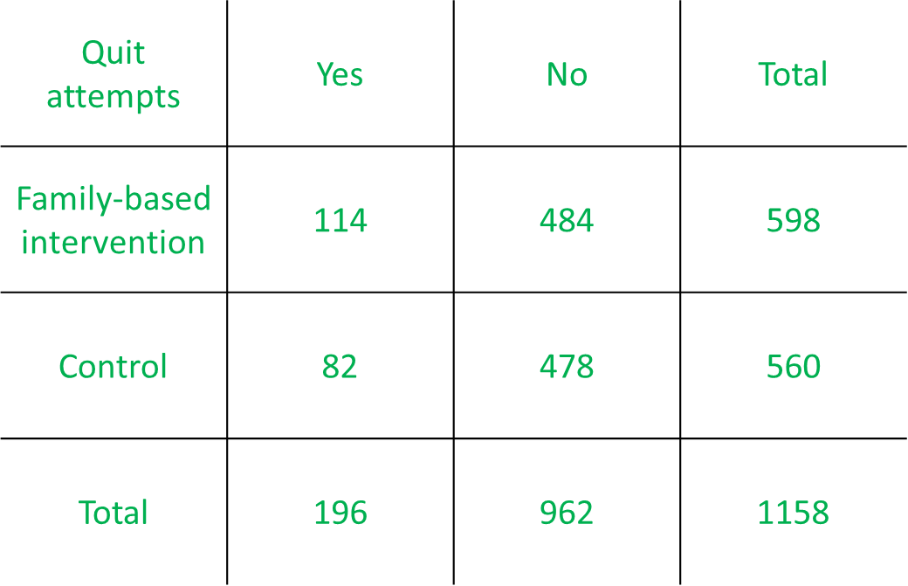
(114/598)/(82/560)=1.3

- Express the RR in words.
Fathers receiving the family-based intervention were 1.3 times as likely to report quit attempts and abstinence for more than 24 hours at 12 month follow-up compared to fathers receiving a leaflet, self-help guide and brief quitting advice.
OR
The risk of reporting quit attempts and abstinence for more than 24 hours at 12 month follow-up was increased by 30% among fathers who received the family-based intervention compared to those who received the leaflet, self-help guide and brief quitting advice

The abstract has been modified for the purpose of this exercise.

