Worksheet: Dichotomous data

Read the abstract below and answer the questions that follow:
Use of malaria rapid diagnostic tests by community health workers in Afghanistan: cluster randomised trial
Toby Leslie, Mark Rowland, Amy Mikhail, Bonnie Cundill, Barbara Willey, Asif Alokozai, Ismail Mayan, Anwar Hasanzai, Sayed Habibullah Baktash, Nader Mohammed, Molly Wood, Habib-U-Rahman Rahimi, Baptiste Laurent, Cyril Buhler, Christopher J M Whitty
BMC Med 2017 Jul 7;15(1):124. doi: 10.1186/s12916-017-0891-8.
Background: The World Health Organisation (WHO) recommends parasitological diagnosis of malaria before treatment, but use of malaria rapid diagnostic tests (mRDTs) by community health workers (CHWs) has not been fully tested within health services in south and central Asia. mRDTs could allow CHWs to diagnose malaria accurately, improving treatment of febrile illness.
Methods: A cluster randomised trial in community health services was undertaken in Afghanistan. The primary outcome was the proportion of suspected malaria cases correctly treated for polymerase chain reaction (PCR)-confirmed malaria and PCR negative cases receiving no antimalarial drugs measured at the level of the patient. CHWs from 22 clusters (clinics) received standard training on clinical diagnosis and treatment of malaria; 11 clusters randomised to the intervention arm received additional training and were provided with mRDTs. CHWs enrolled cases of suspected malaria, and the mRDT results and treatments were compared to blind-read PCR diagnosis.
Results: In total, 256 CHWs enrolled 2400 patients with 2154 (89.8%) evaluated. In the intervention arm, 828 of 1099 patients were treated appropriately vs. 185 of 1055 patients in the control arm. In the control arm, 164 of 191 with confirmed Plasmodium vivax received chloroquine compared to 70 of 155 in the intervention arm. Overuse of chloroquine in the control arm resulted in 813 of 928 with no malaria (PCR negative) being treated vs. 95 of 947 in the intervention arm. In the intervention arm, 30 of 42 patients with P. falciparum did not receive artemisinin-based combination therapy, partly because operational sensitivity of the RDTs was low (53.2%, 38.1-67.9). There was high concordance between recorded RDT result and CHW prescription decisions: 826/950 (87.0%) with a negative test were not prescribed an antimalarial. Co-trimoxazole was prescribed to 62.7% of malaria negative patients in the intervention arm and 15.0% in the control arm.
Conclusions: While introducing mRDT reduced overuse of antimalarials, this action came with risks that need to be considered before use at scale: an appreciable proportion of malaria cases will be missed by those using current mRDTs. Higher sensitivity tests could be used to detect all cases. Overtreatment with antimalarial drugs in the control arm was replaced with increased antibiotic prescription in the intervention arm, resulting in a probable overuse of antibiotics.

Answer the questions below.
- What was the risk of appropriate treatment among patients in the intervention arm?
828/1099=0.75 or 75%
- What was the risk of appropriate treatment among patients in the control arm?
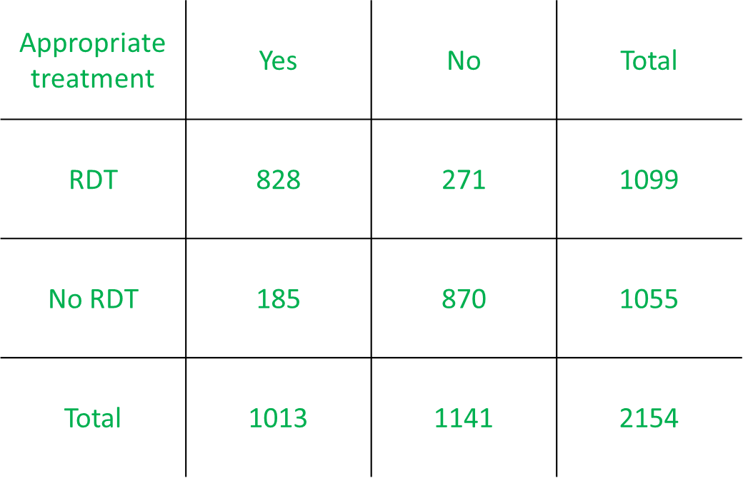
185/1055=0.18 or 18%

- Calculate the relative risk (RR) for the outcome appropriate treatment.
0.75/0.18=4.2
- How would you express the RR in words? Select all that apply. (correct answers highlighted)
- Patients who received the rapid test were 4.2 times as likely to be treated appropriately compared to patients not receiving the test.
- Patients who received the rapid test were 3.2 times as likely to be treated appropriately compared to patients not receiving the test.
- Patients who received the rapid test had a 420% increased risk of being treated appropriately compared to patients not receiving the rest.
- Patients who received the rapid test had a 320% increased risk of being treated appropriately compared to patients not receiving the rest.

- Calculate the odds ratio (OR) for treatment with chloroquine in patients with confirmed Plasmodium vivax infection.
(70/85)/(164/27)=0.14
OR
(70*27)/(164*85)=0.14

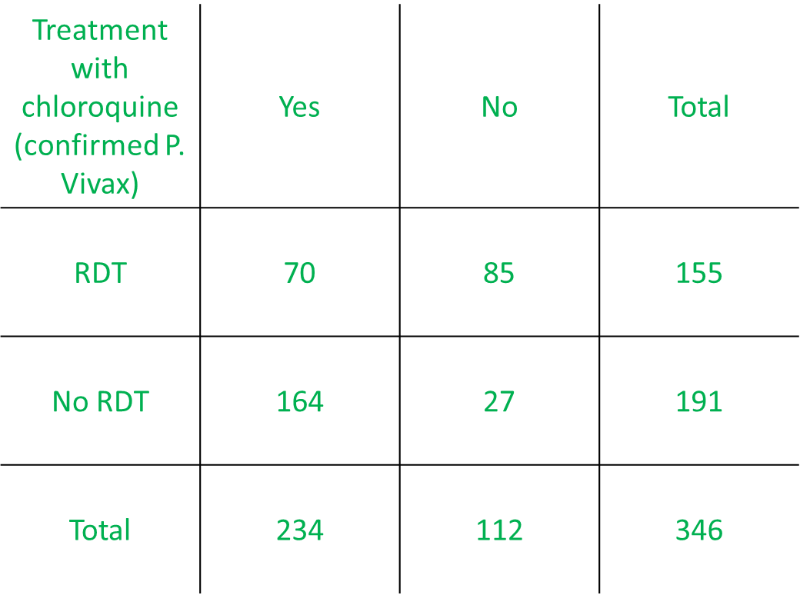
- Express the OR in words.
Patients with confirmed P.Vivax who received a RDT had 0.14 times the odds of being treated with chloroquine compared to those who did not receive ta RDT.
OR
Among patients with confirmed P.Vivax, receiving a RDT reduced the odds of being treated with chloroquine by 84% compared to not receiving a RDT.
- Calculate the RR for overuse of chloroquine in patients with no malaria.
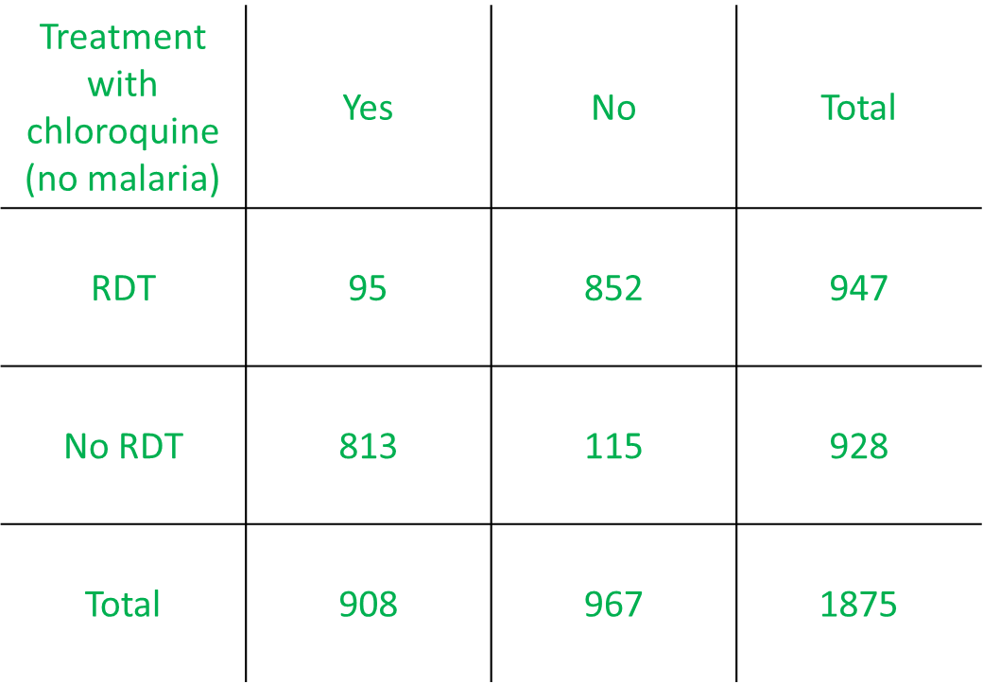
(95/947)/(813/928)=0.1/0.88=0.11
- Express the RR in words.
Among patients with no malaria, the risk of being treated with chloroquine when receiving a RDT was 0.11 the risk when not receiving a RDT.
OR
Among patients with no malaria, the risk of being treated with chloroquine for patients receiving a RDT was 89% less compared to patients not receiving a RDT.

The abstract has been modified for the purpose of this exercise.

