Worksheet: Dichotomous data

Read the abstract below and answer the questions that follow:

The effects of HIV self-testing kits in increasing uptake of male partner testing among pregnant women attending antenatal clinics in Kenya: a randomized controlled trial
Tom Marwa, Sarah Karanja, Justus Osero, Alloys Orago
Pan Afr Med J. 2019 Jul 16;33:213. doi: 10.11604/pamj.2019.33.213.14160. eCollection 2019.
Introduction: HIV self-testing could add a new approach to scaling up HIV testing with potential of being high impact, low cost, confidential, and empowering for users. Methods: Pregnant women attending antenatal clinics (ANC) and their male partners were recruited in 14 clinics in the eastern and central regions of Kenya and randomly allocated to intervention or control arms at a ratio of 1:1:1. Arm 1 received the standard of care, which involved invitation of the male partner to the clinic through word of mouth, arm 2 received an improved invitation letter, and arm 3 received the same improved letter and, two self-testing kits. Analysis was done using adjusted odds ratios (aOR) at 95% confidence intervals (CI) to calculate and determine effects of HIV self-testing in increasing uptake of male partner testing.
Results: A total of 1410 women and 1033 men were recruited; 86% (1217) women and 79% (1107) couples were followed up. In arm 3, 327 of 396 male partners took HIV test, compared to only 133 of 362 male partners in arm 2 and 106 of 375 male partners in arm one. There was a statistical significance between arm one and two (p-value=0.01) while arm three was statistically significant compared to arm two (p-value<0.001).
Conclusion: Giving ANC mothers test kits and improved male invitation letter increased the likelihood of male partner testing by twelve times. These results demonstrate that HIV self-test kits could complement routine HIV testing methods in the general population.
Keywords: ANC mothers; HIV self-testing; drivers and barriers; male involvement; male partners; randomized controlled trial.

Answer the questions below.
- What was the risk of HIV testing uptake among male partners in arm 1?

106/375=0.28 or 28%

- What was the risk of HIV testing uptake among male partners in arm 2?
133/362=0.37 or 37%
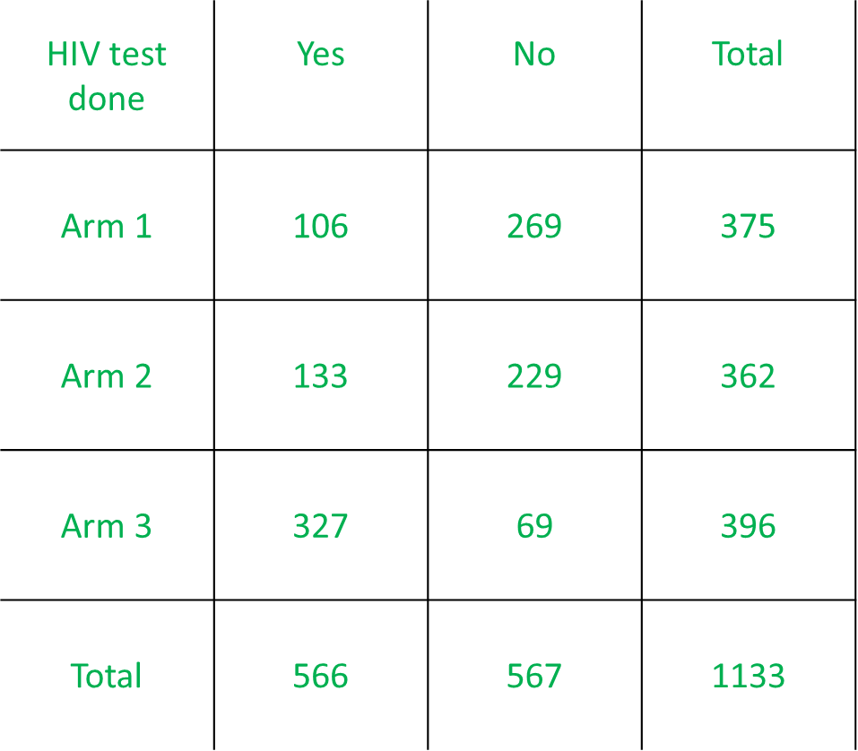
- What was the risk of HIV testing uptake among male partners in arm 3?
327/396=0.83 or 83%
- Calculate the odds ratio (OR) of HIV testing uptake for invitation letters (arm 2) compared to standard care (arm 1).
(133/229)/(106/269)=1.47
OR
(133*269)/(106*229)=1.47
- How would you express the OR in words? Select all that apply. (correct answers highlighted)
- The odds of having an HIV test among male partners receiving standard care was 1.47 the odds of having an HIV test among male partners receiving an invitation letter.
- The odds of having an HIV test among male partners receiving an invitation letter was 1.47 the odds of having an HIV test among male partners receiving standard care.
- Receiving an invitation letter increased the odds of male partners having an HIV test by 47% compared to receiving standard care.
- Receiving standard care increased the odds of male partners having an HIV test by 47% compared to receiving an invitation letter.

- Calculate the risk ratio (RR) of HIV testing uptake for invitation letter and self-testing kits (arm 3) compared to standard care (arm 1).
0.83/0.28=2.96
- Express the RR in words.
Male partners receiving an invitation letter and self-testing kits were 2.96 times as likely to have an HIV test done compared to males receiving standard care.

OR

The risk of having an HIV test done was increased by 196% in male partners that received an invitation letter and self-testing kits, compared to those who only received an invitation letter.

- Calculate the OR of HIV testing uptake for invitation letter and self-testing kits (arm 3) compared to standard care (arm 1).
(327/69)/(106/269)=12.02
OR
(327*269)/106*69)=12.02
- Why is the RR so different from the OR?
Because HIV testing uptake was not a rare outcome

The abstract has been modified for the purpose of this exercise.

