Worksheet: Continuous outcomes
Read the abstract and the extracts of the article below and answer the questions that follow:

Effects of a health educational intervention on malaria knowledge, motivation, and behavioural skills: a randomized controlled trial
Ahmed Dahiru Balami, Salmiah Md Said, Nor Afiah Mohd Zulkefl1, Norsa’adah Bachok and Bala Audu

Malar J 18, 41 (2019). https://doi.org/10.1186/s12936-019-2676-3
Background: The levels of insecticide-treated net use among pregnant women and uptake of intermittent preventive treatment in pregnancy, have been sub-optimal in Nigeria. Previous studies have reported positive correlations between knowledge, attitude and practice of malaria preventive measures. It has also been reported that information and motivation, act through a mediator (behavioural skills), to cause a health behaviour change. The aim of this studywas as such to develop, implement, and assess the effects of a health educational intervention based on the information–motivation–behavioural skills (IMB) model on the levels of knowledge, motivation, and behavioural skills for ITN use and IPTp uptake among pregnant women in a hospital in north-eastern Nigeria.
Methods: This was a randomized controlled parallel-group trial in which 372 antenatal care attendees were randomly assigned to either an intervention or control group after collecting baseline data using a structured questionnaire. The intervention group received a 4-h health education on malaria, guided by a module developed based on the IMB theory, while the control group received health education on breastfeeding for a similar duration and by the same facilitator. Follow-up data were subsequently collected at 2 months and at 4 months post-intervention using the same questionnaire. The generalized linear mixed models analysis was used to determine the between-group and within group effects of the intervention. The intention-to-treat analysis was used after missing data had been replaced. This was followed by a sensitivity analysis, where the analyses were repeated without replacing the missing values.
Results: The intervention was significant in achieving a 12.75% (p < 0.001), 8.55% (p < 0.001), and 6.350% (p < 0.001) higher total knowledge, motivation, and behavioural skills scores respectively, for the intervention group over the control group. The sensitivity analysis revealed no great differences in the effect sizes, even when missing data were not replaced.
Conclusion: The intervention module was effective in improving knowledge, motivation and behavioural skills. It is as such recommended to be adopted and incorporated into the routine antenatal health education schedules. It is also recommended that booster doses of the module be given say 2 months after the first dose to sustain levels of motivation and behavioural skills.

Additional extracts
Methods
Outcome variables and instrument
Follow-up data was collected from participants at 2-months (first follow-up) and at 4 months post-intervention (second follow-up) by the same enumerators, using the same questionnaire. The outcome variables in the study were total knowledge, motivation and behavioural skills scores. The questionnaire consisted of four sections, the first of which was for participants’ socio-demographic characteristics; the second was on knowledge of malaria with questions on malaria transmission, symptoms, complications, ITN and IPT. It had a total of 36 questions, with each question having three options: Yes, No, and I don’t know. A correct answer was scored one point, while a wrong answer or ‘I don’t know’ was scored zero. The sum was calculated to obtain the total knowledge scores for that participant. A difference of 5 points was seen as meaningful. The third section was on motivation, in which personal motivation was assessed by asking participants, how good or bad, and how pleasant or unpleasant sleeping under an ITN and taking IPT was, for them. These comprised of a total of six items, assessed on a Likert scale of 1–5, from very unpleasant to very pleasant. Social motivation was assessed with four items assessed on a Likert scale of 1–6, from not true at all to true all the time. Participants were asked how true or otherwise it was that their significant others would support their use of ITN or IPT. The fourth section assessed behavioural skills with a total of seven items, the first three of which asked of the level of ease or otherwise of carrying the preventive measures, assessed on a Likert scale of 1-5, from very difficult to very easy. The next four asked of how effectively or otherwise the participant could use and care for their ITN, assessed on a Likert scale from 1-5, from very ineffective to very effective. For motivation and behavioural skills, the sum of all the points were calculated to obtain the total motivation and total behavioural skills scores. For motivation, a difference of 10 points was seen as meaningful, and for behavioural skills, a difference of 7 points was seen as meaningful.

Statistical analyses
The data obtained (Additional file 2) was analysed using IBM SPSS version 22. Each of these total scores were converted to percentages of the total obtainable scores for that construct, for further statistical analyses. Normality tests performed on the total knowledge, motivation and behavioural skills scores, using the test of Kurtosis and histogram plots showed there was no substantial non-normality, and as such the data could be handled as normal data.

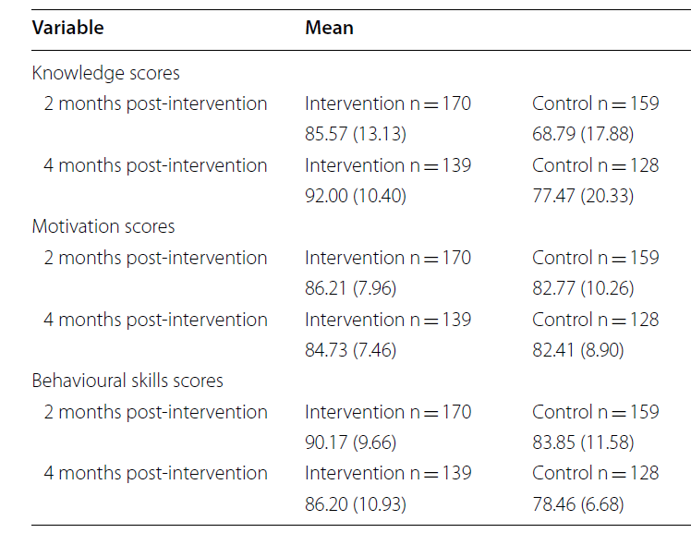
Results
Table 3 Comparison of mean knowledge, motivation, and behavioural skills scores of intervention and control groups at 2 months, and 4 months post-intervention

Question 1: Answer the questions below for the outcome ‘Knowledge’
- How was knowledge measured?
Knowledge was assessed with 36 questions, with each question having three options: Yes, No, and I don’t know. A correct answer was scored one point, while a wrong answer or ‘I don’t know’ was scored zero. The sum was calculated to obtain the total knowledge scores for that participant.
- What was the direction of the scale - was higher or a lower score considered better?
Higher score is better
- What was the length of the scale?

0 to 36
- Is this a good or a bad outcome?
Good
- What was the minimally important difference?
5 points i.e. 14%

Question 2: Answer the questions below for the outcome ‘Behavioural skills’
- How were behavioural skills measured?
Behavioural skills were assessed with a total of seven items in the questionnaire. The first three asked of the level of ease or otherwise of carrying the preventive measures, while the next four asked of how effectively or otherwise the participant could use and care for their ITN. These were assessed on a Likert scale from 1 to 5. The sum of all points was calculated to obtain the total score.

- What was the direction of the scale - was higher or a lower score considered better?
Higher is better
- What was the length of the scale?
7 to 35
- Is this a good or a bad outcome?
good
- What was the minimally important difference?
7 points i.e 20%
Not reported

Question 3: Answer the questions below for the outcome ‘Motivation’
- How was motivation measured?
Motivation was measured in terms of personal motivation and social motivation. Personal motivation was assessed by asking participants, how good or bad, and how pleasant or unpleasant sleeping under an ITN and taking IPT was, for them. These comprised of a total of six items, assessed on a Likert scale of 1–5. Social motivation was assessed with four items assessed on a Likert scale of 1–6. The sum of all the points were calculated to obtain the total motivation
- What was the direction of the scale - was higher or a lower score considered better?
Higher is better
- What was the length of the scale?

10 to 54
- Is this a good or a bad outcome?
Good outcome
- What was the minimally important difference?
10 points i.e 19%

Question 4: Calculate the mean difference between the intervention and control groups at 2 months post-intervention for the following outcomes and express it in words:
- Knowledge
MD = Mean intervention – Mean control = 85.57 – 68.79 = 16.78
At 2-months follow up, the post-intervention knowledge scores were 16.78% higher in the intervention group compared to the control group. This is a meaningful difference, as the minimally important difference was 14%.
- Behavioural skills
MD = Mean intervention – Mean control = 90.17 – 83.85 = 6.31
At 2-months follow up, the post-intervention behavioural skills scores were 6.31% higher in the intervention group compared to the control group. This is not a meaningful difference, as the minimally important difference was 20%.

- Motivation
MD = Mean intervention – Mean control = 86.21 – 82.77 = 3.43
At 2-months follow up, the post-intervention motivation scores were 3.43% higher in the intervention group compared to the control group. This is not a meaningful difference, as the minimally important difference was 19%

Question 5: Calculate the mean difference between the intervention and control groups at 4 months post-intervention for the following outcomes and express it in words:
- Knowledge
MD = Mean intervention – Mean control = 92.00 – 77.47 = 14.54
At 4-months follow up, the post-intervention knowledge scores were 14.54% higher in the intervention group compared to the control group. This is a meaningful difference, as the minimally important difference was 14%.

- Behavioural skills
MD = Mean intervention – Mean control = 86.20 – 78.46 = 7.68
At 4-months follow up, the post-intervention behavioural skills scores were 7.68% higher in the intervention group compared to the control group. This is not a meaningful difference, since the minimally important difference was 20%

- Motivation

MD = Mean intervention – Mean control = 84.73 – 82.41 = 2.32
At 4-months follow up, the post-intervention motivation scores were 2.32% higher in the intervention group compared to the control group. This is not a meaningful difference, as the minimally important difference was 19%.

The content of these extracts has been modified for the purpose of this exercise

