Worksheet: Continuous outcomes
Read the abstract and the extracts of the article below and answer the questions that follow:

Effect of Exercise Intervention on Functional Decline in Very Elderly Patients During Acute Hospitalization A Randomized Clinical Trial

Nicolás Martínez-Velilla; Alvaro Casas-Herrero; Fabricio Zambom-Ferraresi; Mikel L. Sáez de Asteasu; Alejandro Lucia; Arkaitz Galbete; Agurne García-Baztán; Javier Alonso-Renedo; Belen González-Glaría; María Gonzalo-Lázaro; Itziar Apezteguía Iráizoz; Marta Gutiérrez-Valencia; Leocadio Rodríguez-Mañas; Mikel Izquierdo
JAMA Intern Med. 2019;179(1):28-36. doi:10.1001/jamainternmed.2018.4869
Importance: Functional decline is prevalent among acutely hospitalized older patients. Exercise and early rehabilitation protocols applied during acute hospitalization can prevent functional and cognitive decline in older patients.
Objective: To assess the effects of an innovative multicomponent exercise intervention on the functional status of this patient population.
Design, setting, and participants: A single-center, single-blind randomized clinical trial was conducted from February 1, 2015, to August 30, 2017, in an acute care unit in a tertiary public hospital in Navarra, Spain. A total of 370 very elderly patients undergoing acute-care hospitalization were randomly assigned to an exercise or control (usual-care) intervention. Intention-to-treat analysis was conducted.
Interventions: The control group received usual-care hospital care, which included physical rehabilitation when needed. The in-hospital intervention included individualized moderate-intensity resistance, balance, and walking exercises (2 daily sessions).
Main outcomes and measures: The primary end point was change in functional capacity from baseline to hospital discharge, assessed with the Barthel Index of independence and the Short Physical Performance Battery (SPPB). Secondary end points were changes in cognitive and mood status, quality of life, handgrip strength, incident delirium, length of stay, falls, transfer after discharge, and readmission rate and mortality at 3 months after discharge.
Results: Of the 370 patients included in the analyses, 209 were women (56.5%); mean (SD) age was 87.3 (4.9) years. The median length of hospital stay was 8 days in both groups (interquartile range, 4 and 4 days, respectively). Median duration of the intervention was 5 days (interquartile range, 0); there was a mean (SD) of 5 (1) morning and 4 (1) evening sessions per patient. No adverse effects were observed with the intervention. The exercise intervention program provided significant benefits over usual care. Hospitalization led to an impairment in functional capacity in the usual-care group, whereas the exercise intervention reversed this trend. The intervention also improved the SPPB score. Significant intervention benefits were also found at the cognitive level over the usual-care group.
Conclusions and relevance: The exercise intervention proved to be safe and effective to reverse the functional decline associated with acute hospitalization in very elderly patients.

Additional extracts
Methods
End Points
The primary end point was change in functional capacity from baseline (beginning of the intervention) to hospital discharge, as assessed with the Short Physical Performance Battery (SPPB), which combines balance, gait velocity, and leg strength as a single score on a 0 (worst) to 12 (best scale), and the Barthel Index of independence during activities of daily living (ADLs) from 2 weeks prior to admission to hospital discharge. The magnitude of meaningful change (ie, clinically significant) was 1 point for the SPPB and 5 points for the Barthel Index.

Secondary end points included changes in cognitive capacity as assessed with the Mini-Mental State Examination (30-point questionnaire; scale of 0 [worst] to 30 [best]), mood status (15-item Yesavage Geriatric Depression Scale; Spanish version; scale of 0 [best] to 15 [worst]), visual analog scale of the EuroQol–5 Dimension (EQ-5D) questionnaire for quality of life (QoL) assessment (Spanish version of the EQ-5D32; scale of 0 [worst health state imaginable] to 100 [best health state imaginable]), and handgrip strength (dominant hand). Other secondary end points included development of delirium (as assessed with the Confusion Assessment Method; feature 1, acute onset and fluctuating course; feature 2, inattention; feature 3, disorganized thinking; and feature 4, altered level of consciousness, with diagnosis of delirium requiring the presence of features 1 and 2 and either 3 or 4), length of hospital stay, falls during hospitalization, transfer after discharge, and readmission rate and mortality at 3 months after discharge.

Statistical Analysis
We used the intention-to-treat approach. Between-group comparisons of continuous variables were conducted using linear mixed models. Time was treated as a categorical variable. The models included group, time, and group by time interaction as fixed effects, and participants as random effect. For each group, data are expressed as change from baseline (admission) to discharge, determined by the time coefficients (95% CI) of the model. The primary conclusions about effectiveness of exercise intervention were based on between-group comparisons of change in functional capacity from baseline (beginning of the intervention) to hospital discharge, as assessed with the SPPB and the Barthel Index of independence during ADLs and determined by the time by group interaction coefficients of the model.

Results

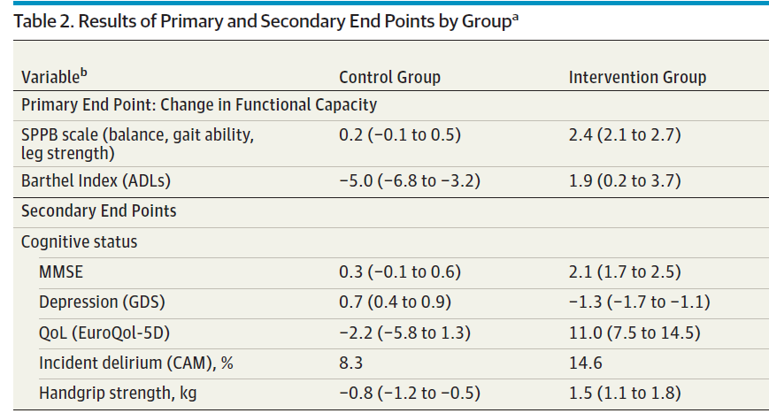

Abbreviations: ADLs, activities of daily living; CAM, Confusion Assessment Method; EurolQol-5D, EuroQol Questionnaire–5 Dimensions; GDS, Yesavage Geriatric Depression Scale; MMSE, Mini-Mental State Examination; OR, odds ratio; QoL, quality of life; SPPB, Short Physical Performance Battery.
ªAll data, except for CAM, were derived from linear mixed-effects model. For each group, data are expressed as change from baseline (admission) to discharge, determined by the time coefficients (95% CI) of the model. For example, for the SPPB scale, 0.2 corresponds to the coefficient estimated from the model. The between-group difference was determined with time × group interaction coefficient. For CAM, data are the proportion of patients in whom delirium developed.
The Barthel Index ranges from 0 (severe functional dependence) to 100 (functional independence).

Question 1: Answer the questions below for the outcome ‘Functional capacity’
- What tool was used to measure functional capacity?

- What was the direction of the scale - was higher or a lower score considered better?

- What was the length of the scale?

- Is this a good or a bad outcome?

- What was the minimally important difference?

Question 2: Answer the questions below for the outcome ‘Independence during activities of daily living’
- What tool was used to measure independence during activities of daily living?

- What was the direction of the scale - was higher or a lower score considered better?

- What was the length of the scale?

- Is this a good or a bad outcome?

- What was the minimally important difference?

Question 3: Answer the questions below for the outcome ‘Cognitive capacity’
- What tool was used to measure cognitive capacity?

- What was the direction of the scale - was higher or a lower score considered better?

- What was the length of the scale?

- Is this a good or a bad outcome?

- What was the minimally important difference?

Question 4: Answer the questions below for the outcome ‘Mood status’
- What tool was used to measure mood status?

- What was the direction of the scale - was higher or a lower score considered better?

- What was the length of the scale?

- Is this a good or a bad outcome?

- What was the minimally important difference?

Question 5: Answer the questions below for the outcome ‘Quality of life’
- What tool was used to measure quality of life?

- What was the direction of the scale - was higher or a lower score considered better?

- What was the length of the scale?

- Is this a good or a bad outcome?

- What was the minimally important difference?

Question 6: Calculate the mean difference (MD) in change from baseline to follow-up between the intervention and control groups for the following outcomes and express it in words:
- Functional Capacity

- Independence during activities of daily living

- Cognitive capacity

- Mood status

- Quality of life

The abstract has been modified for the purpose of this exercise

